**Predicting Future Promising Technologies using LSTM**

*The Journal of Technology Transfer*

Seol-Hyun Noh*

*Corresponding author: Seol-Hyun Noh

Department of Statistical Data Science, ICT Convergence Engineering, Anyang University

Samdeok-ro 37 beon-gil 22, Manan-gu, Anyang, Gyeonggi-do 14028, Korea

E-mail: shnoh@anyang.ac.kr

**Supplementary Data**

1. Patent Analysis Data
2. Augmented reality

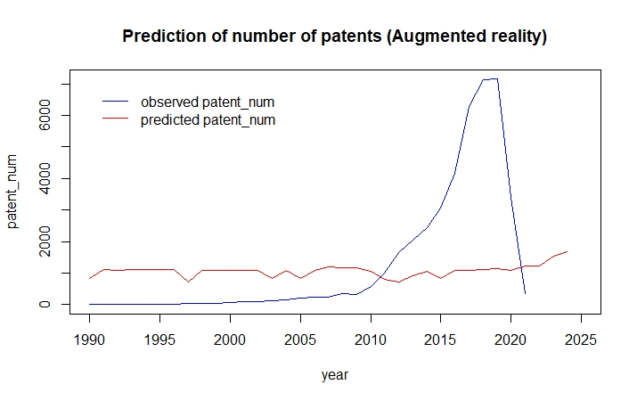

1. Collaborative Telepresence

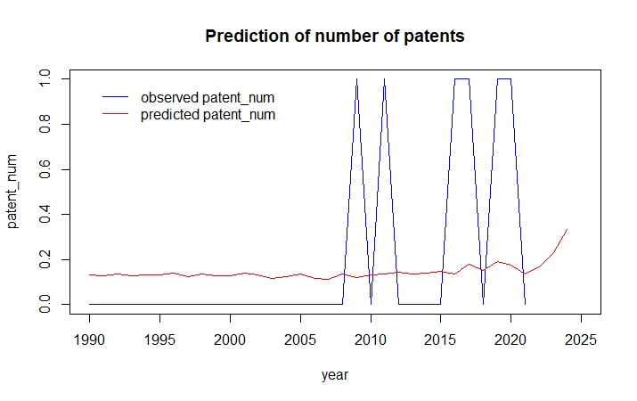

|  |  |  |  |
| --- | --- | --- | --- |
| word | TF | DF | TF_IDF |
| segment | 14 | 2 | 9.70406053 |
| object | 7 | 1 | 7.69028602 |
| candidates | 10 | 2 | 6.93147181 |
| target | 6 | 1 | 6.59167373 |
| devices | 8 | 2 | 5.54517744 |
| electronic | 8 | 2 | 5.54517744 |
| physical | 4 | 1 | 4.39444915 |
| set | 4 | 1 | 4.39444915 |
| beacon | 6 | 2 | 4.15888308 |
| device | 6 | 2 | 4.15888308 |
| receivercontroller | 6 | 2 | 4.15888308 |
| submitted | 6 | 2 | 4.15888308 |
| work | 6 | 2 | 4.15888308 |
| data | 3 | 1 | 3.29583687 |
| information | 3 | 1 | 3.29583687 |
| visual | 3 | 1 | 3.29583687 |
| coupled | 4 | 2 | 2.77258872 |
| candidate | 4 | 2 | 2.77258872 |
| network | 4 | 2 | 2.77258872 |
| plurality | 4 | 2 | 2.77258872 |
| votes | 4 | 2 | 2.77258872 |
| voting | 4 | 2 | 2.77258872 |
| audience | 6 | 3 | 2.43279065 |
| avatars | 2 | 1 | 2.19722458 |
| determined | 2 | 1 | 2.19722458 |
| displayed | 2 | 1 | 2.19722458 |
| element | 2 | 1 | 2.19722458 |
| lampsbased | 2 | 1 | 2.19722458 |
| mapped | 2 | 1 | 2.19722458 |
| objects | 2 | 1 | 2.19722458 |

1. Digital Medicine

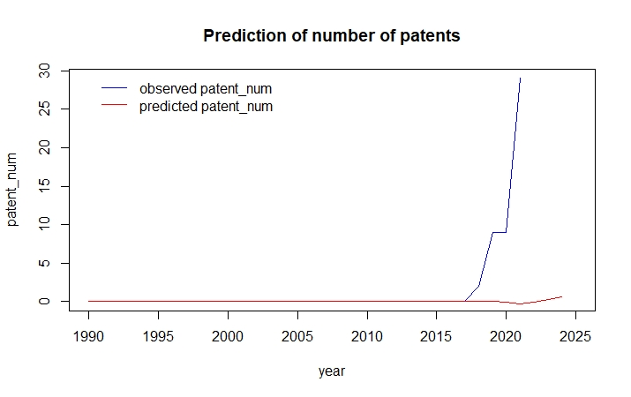

|  |  |  |  |
| --- | --- | --- | --- |
| word | TF | DF | TF_IDF |
| medical | 48 | 8 | 85.1072321 |
| dataset | 46 | 11 | 68.3277221 |
| device | 70 | 19 | 68.2191748 |
| data | 95 | 26 | 64.0732295 |
| image | 27 | 6 | 54.6583076 |
| content | 20 | 3 | 51.679951 |
| delivery | 20 | 4 | 47.21708 |
| user | 50 | 21 | 43.962473 |
| medication | 17 | 3 | 43.9279584 |
| drug | 13 | 1 | 42.6028815 |
| learning | 22 | 7 | 41.5987082 |
| communication | 28 | 11 | 41.5907874 |
| microbiome | 20 | 6 | 40.4876353 |
| images | 22 | 8 | 39.0074814 |
| set | 35 | 17 | 37.7972054 |
| supplementary | 25 | 11 | 37.1346316 |
| gan | 14 | 3 | 36.1759657 |
| patient | 19 | 7 | 35.9261571 |
| devices | 20 | 8 | 35.4613467 |
| condition | 26 | 13 | 34.6120992 |
| andor | 23 | 11 | 34.1638611 |
| program | 19 | 8 | 33.6882794 |
| model | 19 | 8 | 33.6882794 |
| ingestible | 13 | 3 | 33.5919682 |
| system | 70 | 32 | 33.1649046 |
| active | 14 | 4 | 33.051956 |
| group | 10 | 1 | 32.7714473 |
| information | 16 | 6 | 32.3901082 |
| care | 16 | 6 | 32.3901082 |
| configured | 24 | 13 | 31.94963 |

1. DNA Data Storage

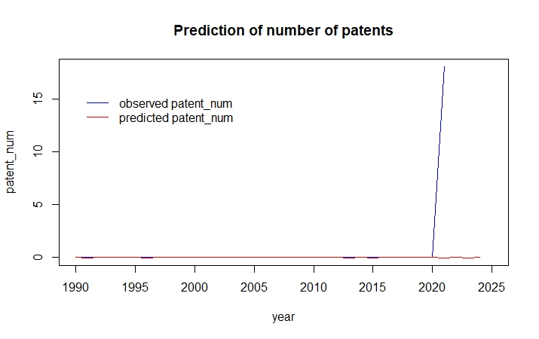

|  |  |  |  |
| --- | --- | --- | --- |
| word | TF | DF | TF_IDF |
| end | 13 | 1 | 29.9336062 |
| data | 56 | 11 | 28.6062349 |
| linker | 12 | 1 | 27.6310211 |
| nucleic | 30 | 8 | 23.9552309 |
| vdna | 10 | 1 | 23.0258509 |
| library | 19 | 5 | 22.8754833 |
| acid | 28 | 8 | 22.3582155 |
| sequence | 23 | 7 | 21.0746868 |
| dna | 42 | 12 | 18.0928825 |
| molecules | 13 | 4 | 18.0218267 |
| symbol | 9 | 2 | 17.0740799 |
| polynucleotides | 7 | 1 | 16.1180957 |
| vesicles | 7 | 1 | 16.1180957 |
| synthesis | 13 | 5 | 15.6516465 |
| polymer | 6 | 1 | 13.8155106 |
| fragment | 6 | 1 | 13.8155106 |
| overhanging | 6 | 1 | 13.8155106 |
| techniques | 8 | 3 | 12.8755033 |
| strands | 8 | 3 | 12.8755033 |
| information | 13 | 7 | 11.9117795 |
| hash | 5 | 1 | 11.5129255 |
| homopolymer | 6 | 2 | 11.3827199 |
| memory | 6 | 2 | 11.3827199 |
| tracts | 6 | 2 | 11.3827199 |
| associated | 6 | 2 | 11.3827199 |
| system | 7 | 3 | 11.2660654 |
| encoding | 11 | 7 | 10.0791981 |
| libraries | 6 | 3 | 9.65662747 |
| nucleotides | 6 | 3 | 9.65662747 |
| embodiments | 6 | 3 | 9.65662747 |

1. Electric Aviation

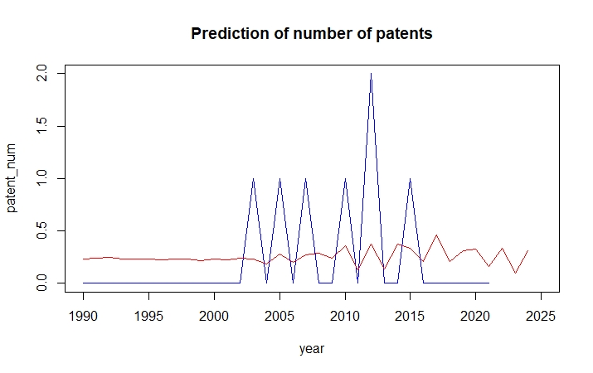

|  |  |  |  |
| --- | --- | --- | --- |
| word | TF | DF | TF_IDF |
| system | 19 | 2 | 16.0986593 |
| driver | 8 | 1 | 10.0221037 |
| fuel | 11 | 2 | 9.32027646 |
| interface | 10 | 2 | 8.4729786 |
| control | 9 | 2 | 7.62568074 |
| cavity | 6 | 1 | 7.51657781 |
| powder | 6 | 1 | 7.51657781 |
| method | 10 | 3 | 5.59615788 |
| surface | 4 | 1 | 5.01105187 |
| enclosure | 4 | 1 | 5.01105187 |
| blade | 8 | 3 | 4.4769263 |
| coupling | 5 | 2 | 4.2364893 |
| engine | 5 | 2 | 4.2364893 |
| portion | 5 | 2 | 4.2364893 |
| airfoil | 5 | 2 | 4.2364893 |
| onboard | 3 | 1 | 3.75828891 |
| vtol | 3 | 1 | 3.75828891 |
| fsi1 | 3 | 1 | 3.75828891 |
| fsi2 | 3 | 1 | 3.75828891 |
| articles | 3 | 1 | 3.75828891 |
| different | 3 | 1 | 3.75828891 |
| layer | 3 | 1 | 3.75828891 |
| platform | 3 | 1 | 3.75828891 |
| platinum | 3 | 1 | 3.75828891 |
| overspeed | 4 | 2 | 3.38919144 |
| gas | 10 | 4 | 3.36472237 |
| coating | 5 | 3 | 2.79807894 |
| least | 3 | 2 | 2.54189358 |
| aircraft | 2 | 1 | 2.50552594 |
| electric | 2 | 1 | 2.50552594 |

1. Electroceuticals

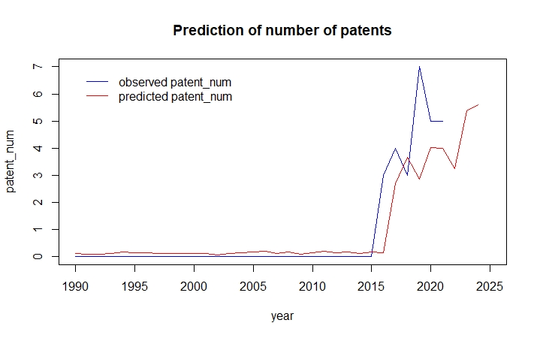

|  |  |  |  |
| --- | --- | --- | --- |
| word | TF | DF | TF_IDF |
| implantable | 50 | 10 | 44.8970797 |
| configured | 47 | 10 | 42.2032549 |
| signal | 34 | 7 | 41.357441 |
| pain | 18 | 2 | 39.5500424 |
| circuit | 26 | 5 | 39.1060123 |
| ultrasonic | 31 | 8 | 34.0569809 |
| therapy | 17 | 3 | 32.4622226 |
| described | 27 | 8 | 29.6625318 |
| electrical | 24 | 7 | 29.1934878 |
| patient | 15 | 3 | 28.6431376 |
| cancer | 21 | 6 | 28.3484611 |
| information | 12 | 2 | 26.3666949 |
| power | 19 | 6 | 25.6486076 |
| devices | 30 | 11 | 24.3279065 |
| tissue | 18 | 6 | 24.2986809 |
| fiber | 9 | 1 | 23.4242072 |
| material | 9 | 1 | 23.4242072 |
| data | 17 | 6 | 22.9487542 |
| management | 12 | 3 | 22.9145101 |
| trigger | 13 | 4 | 21.9231864 |
| device | 33 | 13 | 21.6737247 |
| analyte | 12 | 4 | 20.2367874 |
| pressure | 12 | 4 | 20.2367874 |
| temperature | 12 | 4 | 20.2367874 |
| amount | 13 | 5 | 19.5530062 |
| cells | 14 | 6 | 18.898974 |
| stimulation | 7 | 1 | 18.2188278 |
| processor | 7 | 1 | 18.2188278 |
| emit | 18 | 9 | 17.8785319 |
| embodiments | 8 | 2 | 17.5777966 |

1. Gene drive

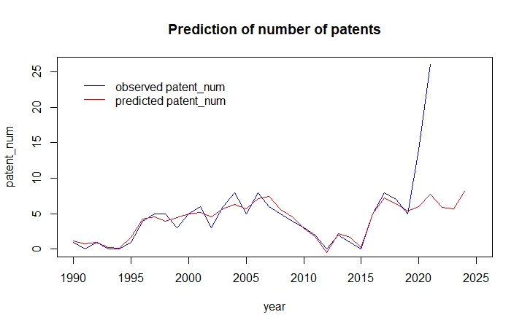

|  |  |  |  |
| --- | --- | --- | --- |
| word | TF | DF | TF_IDF |
| nucleic | 105 | 40 | 137.582388 |
| prostate | 64 | 17 | 136.544561 |
| invention | 168 | 74 | 118.673924 |
| polypeptides | 50 | 14 | 115.791516 |
| cells | 75 | 33 | 112.314 |
| gene | 114 | 57 | 109.831876 |
| expression | 85 | 43 | 105.373725 |
| dna | 65 | 30 | 103.343066 |
| acid | 71 | 36 | 100.320345 |
| proteins | 41 | 13 | 97.7777508 |
| acids | 63 | 32 | 96.2244964 |
| cell | 70 | 39 | 93.4500747 |
| protein | 55 | 28 | 91.112158 |
| delta6desaturase | 32 | 8 | 90.4529902 |
| present | 70 | 42 | 88.3876284 |
| relates | 50 | 25 | 88.2891991 |
| isolated | 45 | 24 | 81.2252113 |
| sequence | 51 | 31 | 79.4653755 |
| methods | 102 | 70 | 77.6424657 |
| vhh1 | 19 | 2 | 74.5800964 |
| encoding | 43 | 27 | 72.7420685 |
| comprising | 54 | 39 | 72.0900576 |
| least | 34 | 18 | 70.7010124 |
| antigen | 33 | 17 | 70.4057892 |
| human | 29 | 13 | 69.1598725 |
| genetic | 25 | 9 | 68.0323857 |
| compositions | 45 | 34 | 66.0839607 |
| genes | 30 | 16 | 65.7200153 |
| recombinant | 34 | 21 | 65.7164943 |
| plants | 32 | 19 | 64.9007439 |

1. Green ammonia

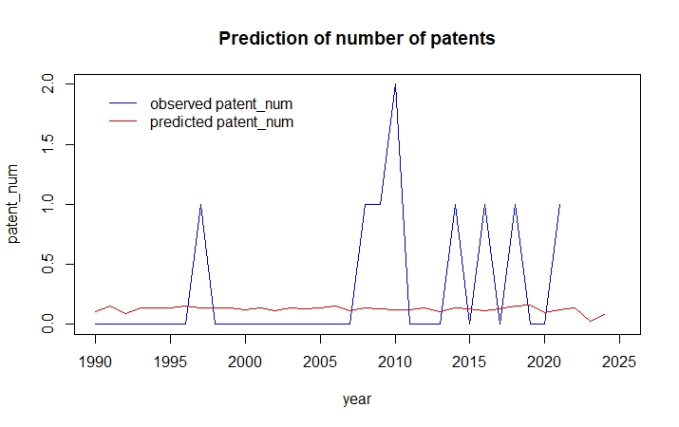

|  |  |  |  |
| --- | --- | --- | --- |
| word | TF | DF | TF_IDF |
| hydrogen | 8 | 1 | 14.3340758 |
| canisters | 10 | 2 | 13.8629436 |
| filter | 10 | 2 | 13.8629436 |
| reaction | 13 | 4 | 11.3810936 |
| activated | 8 | 2 | 11.0903549 |
| charcoal | 8 | 2 | 11.0903549 |
| article | 6 | 1 | 10.7505568 |
| odor | 6 | 1 | 10.7505568 |
| sensing | 9 | 3 | 9.8875106 |
| indicating | 5 | 1 | 8.95879735 |
| ammonia | 12 | 5 | 8.31776617 |
| acid | 7 | 3 | 7.69028602 |
| cracking | 4 | 1 | 7.16703788 |
| unit | 4 | 1 | 7.16703788 |
| absorbing | 4 | 1 | 7.16703788 |
| agent | 4 | 1 | 7.16703788 |
| odors | 4 | 1 | 7.16703788 |
| visual | 4 | 1 | 7.16703788 |
| medium | 4 | 1 | 7.16703788 |
| combination | 6 | 3 | 6.59167373 |
| distinct | 6 | 3 | 6.59167373 |
| dyes | 6 | 3 | 6.59167373 |
| element | 6 | 3 | 6.59167373 |
| identity | 6 | 3 | 6.59167373 |
| microorganism | 6 | 3 | 6.59167373 |
| presence | 6 | 3 | 6.59167373 |
| quantity | 6 | 3 | 6.59167373 |
| copperiiammonia | 6 | 3 | 6.59167373 |
| hydroxide | 6 | 3 | 6.59167373 |
| muconic | 6 | 3 | 6.59167373 |

1. Green Hydrogen

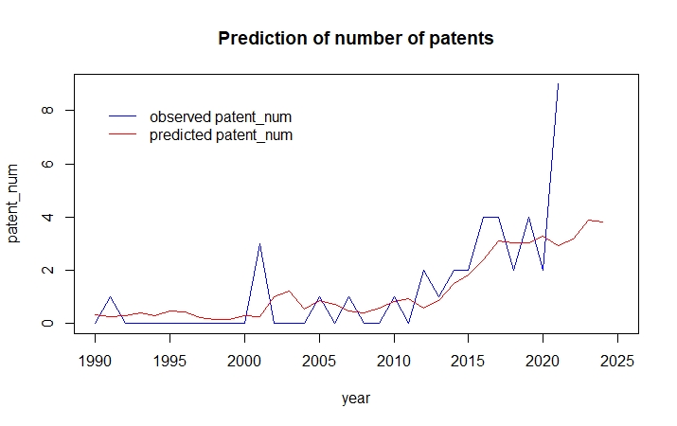

|  |  |  |  |
| --- | --- | --- | --- |
| word | TF | DF | TF_IDF |
| hydrogen | 45 | 15 | 44.4875127 |
| gas | 25 | 8 | 39.0993885 |
| acid | 28 | 10 | 38.1725356 |
| compounds | 17 | 6 | 30.8599294 |
| node | 10 | 1 | 30.6805294 |
| methods | 20 | 9 | 29.1723005 |
| power | 18 | 9 | 26.2550704 |
| comprising | 19 | 10 | 25.902792 |
| oxide | 12 | 4 | 25.8211464 |
| aqueous | 13 | 5 | 25.6027284 |
| charge | 8 | 1 | 24.5444235 |
| plasma | 9 | 2 | 23.9632904 |
| light | 9 | 2 | 23.9632904 |
| magnesium | 10 | 3 | 23.7490575 |
| molecule | 10 | 3 | 23.7490575 |
| system | 18 | 11 | 22.9732824 |
| optical | 7 | 1 | 21.4763705 |
| molecules | 9 | 3 | 21.3741518 |
| calcium | 8 | 2 | 21.3007026 |
| polymer | 8 | 2 | 21.3007026 |
| tubulin | 8 | 2 | 21.3007026 |
| producing | 10 | 5 | 19.6944065 |
| least | 10 | 5 | 19.6944065 |
| material | 9 | 4 | 19.3658598 |
| method | 16 | 12 | 19.1400121 |
| compound | 8 | 3 | 18.999246 |
| process | 12 | 8 | 18.7677065 |
| sulfuric | 7 | 2 | 18.6381148 |
| beam | 7 | 2 | 18.6381148 |
| boron | 7 | 2 | 18.6381148 |

1. Personalized medicine

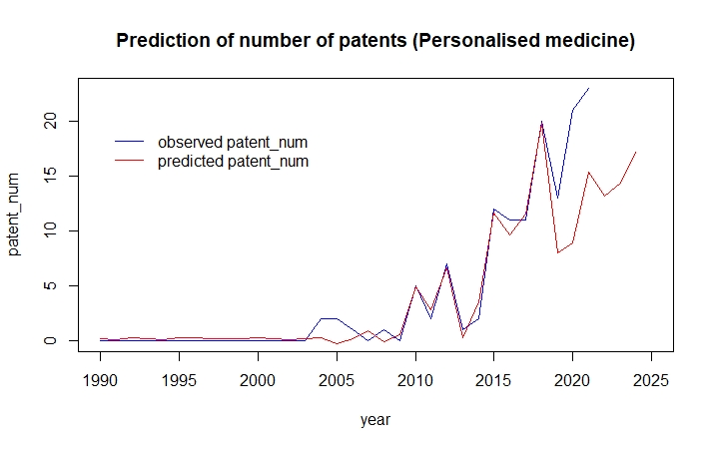

|  |  |  |  |
| --- | --- | --- | --- |
| word | TF | DF | TF_IDF |
| data | 53 | 13 | 119.715471 |
| image | 30 | 4 | 98.6520566 |
| cells | 52 | 20 | 96.3725028 |
| sample | 50 | 19 | 95.1053763 |
| compounds | 56 | 29 | 83.8119754 |
| method | 67 | 38 | 82.6966363 |
| phase | 23 | 3 | 80.7655451 |
| present | 71 | 45 | 75.9130866 |
| cell | 56 | 34 | 75.1795374 |
| cancer | 40 | 21 | 72.2718939 |
| relates | 79 | 53 | 71.7996045 |
| solid | 23 | 5 | 71.4398476 |
| methods | 70 | 48 | 70.4213651 |
| subject | 36 | 18 | 70.3224295 |
| expression | 28 | 10 | 69.9984468 |
| invention | 92 | 63 | 67.9840179 |
| region | 25 | 8 | 67.5153806 |
| treatment | 63 | 45 | 67.3594994 |
| fluid | 22 | 6 | 64.9424523 |
| comparator | 16 | 2 | 60.7876402 |
| agent | 25 | 11 | 60.3233288 |
| comprising | 53 | 42 | 60.2419033 |
| set | 18 | 4 | 59.191234 |
| moiety | 21 | 8 | 56.7129197 |
| targeting | 21 | 8 | 56.7129197 |
| binding | 24 | 12 | 55.9893706 |
| system | 29 | 19 | 55.1611183 |
| patient | 20 | 8 | 54.0123045 |
| andor | 29 | 20 | 53.7462035 |
| compositions | 39 | 33 | 53.4876917 |

1. Plasmonic materials

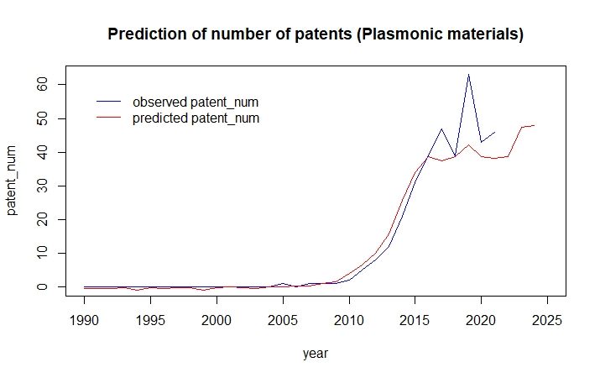

|  |  |  |  |
| --- | --- | --- | --- |
| word | TF | DF | TF_IDF |
| layer | 355 | 103 | 442.77 |
| material | 353 | 124 | 375.36 |
| surface | 326 | 130 | 331.36 |
| structure | 158 | 49 | 312.78 |
| peg | 133 | 36 | 303.34 |
| light | 194 | 78 | 295.31 |
| optical | 158 | 59 | 283.97 |
| region | 108 | 26 | 280.35 |
| waveguide | 126 | 50 | 246.94 |
| plasmonic | 206 | 111 | 241.67 |
| metal | 105 | 39 | 231.29 |
| devices | 166 | 91 | 227.40 |
| transducer | 186 | 106 | 226.70 |
| least | 179 | 102 | 224.99 |
| positioned | 109 | 46 | 222.52 |
| magnetic | 105 | 43 | 221.28 |
| portion | 114 | 51 | 221.21 |
| substrate | 150 | 84 | 217.35 |
| nft | 109 | 50 | 213.62 |
| dielectric | 102 | 44 | 212.67 |
| nearfield | 100 | 48 | 199.98 |
| oxide | 69 | 21 | 193.24 |
| configured | 105 | 59 | 188.72 |
| device | 115 | 74 | 181.03 |
| field | 131 | 90 | 180.88 |
| film | 70 | 29 | 174.33 |
| thereof | 73 | 33 | 172.67 |
| conductive | 70 | 30 | 172.04 |
| electromagnetic | 66 | 26 | 171.32 |

1. Quantum Sensing

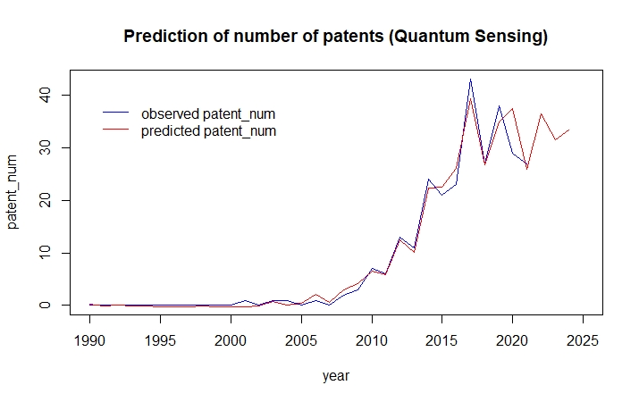

|  |  |  |  |
| --- | --- | --- | --- |
| word | TF | DF | TF_IDF |
| layer | 203 | 45 | 369.53 |
| material | 285 | 93 | 315.12 |
| light | 181 | 54 | 297.14 |
| quantum | 152 | 42 | 286.94 |
| diamond | 150 | 41 | 286.70 |
| optical | 180 | 59 | 279.83 |
| magnetic | 171 | 67 | 244.44 |
| spin | 80 | 13 | 240.79 |
| field | 122 | 47 | 216.89 |
| excitation | 97 | 32 | 208.79 |
| device | 183 | 90 | 208.27 |
| semiconductor | 132 | 58 | 207.43 |
| nanometers | 48 | 4 | 193.90 |
| configured | 124 | 59 | 192.77 |
| signal | 102 | 42 | 192.55 |
| region | 72 | 20 | 187.52 |
| substrate | 105 | 49 | 182.38 |
| source | 98 | 44 | 180.55 |
| surface | 90 | 41 | 172.02 |
| frequency | 83 | 39 | 162.69 |
| defect | 61 | 19 | 161.85 |
| diode | 55 | 14 | 161.75 |
| detector | 97 | 56 | 155.77 |
| system | 87 | 53 | 144.42 |
| sensor | 61 | 26 | 143.54 |
| magnetooptical | 46 | 12 | 141.87 |
| unit | 41 | 8 | 141.52 |
| micro | 44 | 11 | 139.22 |
| array | 57 | 25 | 136.28 |

1. Social Robots

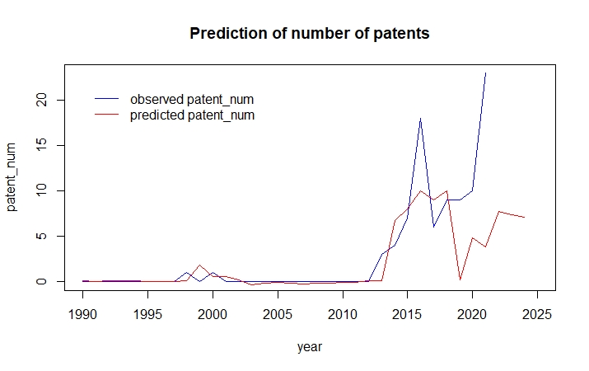

|  |  |  |  |
| --- | --- | --- | --- |
| word | TF | DF | TF_IDF |
| patient | 89 | 9 | 196.536423 |
| robot | 138 | 29 | 153.133373 |
| monitoring | 85 | 17 | 137.741459 |
| information | 97 | 29 | 107.637226 |
| system | 124 | 38 | 105.064935 |
| optical | 45 | 8 | 104.113572 |
| social | 74 | 22 | 101.777032 |
| task | 43 | 8 | 99.486302 |
| least | 143 | 45 | 97.5571897 |
| user | 74 | 25 | 92.7044597 |
| sensor | 55 | 17 | 89.1268262 |
| device | 139 | 48 | 86.04645 |
| telemetry | 45 | 14 | 81.1264187 |
| signal | 32 | 8 | 74.0363177 |
| network | 40 | 15 | 69.5308314 |
| image | 30 | 8 | 69.4090479 |
| video | 27 | 6 | 69.2536327 |
| snet | 26 | 6 | 66.6886833 |
| dialog | 18 | 2 | 61.4204499 |
| object | 35 | 15 | 60.8394774 |
| data | 48 | 25 | 60.1326225 |
| content | 23 | 6 | 58.9938352 |
| method | 50 | 27 | 58.9327498 |
| circuitry | 34 | 16 | 57.0399695 |
| human | 35 | 17 | 56.7170712 |
| detector | 22 | 6 | 56.4288859 |
| set | 26 | 10 | 54.9370701 |
| services | 20 | 5 | 54.3820007 |
| sensors | 33 | 17 | 53.4760957 |
| action | 26 | 11 | 52.6747743 |

1. Spatial Computing

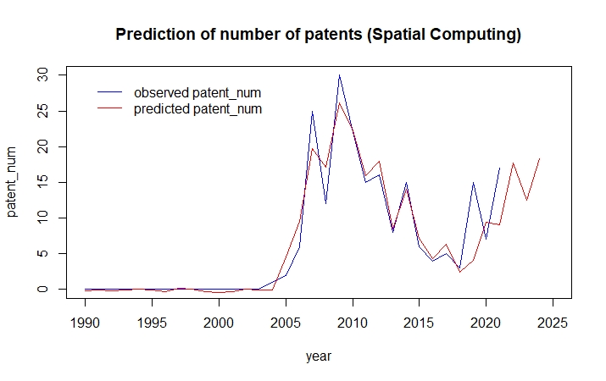

|  |  |  |  |
| --- | --- | --- | --- |
| word | TF | DF | TF_IDF |
| configurable | 453 | 109 | 297.215977 |
| data | 318 | 84 | 290.631336 |
| circuits | 361 | 104 | 253.647959 |
| configuration | 158 | 42 | 252.071013 |
| set | 382 | 111 | 243.749388 |
| memory | 109 | 27 | 220.657612 |
| routing | 108 | 27 | 218.633231 |
| circuit | 355 | 115 | 214.06361 |
| logic | 164 | 58 | 209.764008 |
| tile | 72 | 12 | 200.997858 |
| input | 125 | 43 | 196.54958 |
| reconfigurable | 86 | 25 | 180.470117 |
| method | 128 | 53 | 175.053085 |
| nodes | 76 | 21 | 172.18133 |
| several | 181 | 82 | 169.731966 |
| storage | 79 | 26 | 162.799203 |
| device | 75 | 28 | 149.196783 |
| system | 77 | 30 | 148.040128 |
| user | 69 | 26 | 142.191709 |
| interconnect | 84 | 39 | 140.087373 |
| nanoscale | 45 | 9 | 137.430053 |
| particular | 106 | 57 | 137.391186 |
| least | 172 | 95 | 136.26495 |
| elements | 69 | 30 | 132.659336 |
| array | 69 | 30 | 132.659336 |
| operation | 81 | 42 | 129.226279 |
| design | 58 | 22 | 128.823339 |
| plurality | 65 | 29 | 127.100278 |
| fabric | 40 | 8 | 126.374468 |
| signal | 72 | 37 | 123.768008 |

1. Virtual Patients

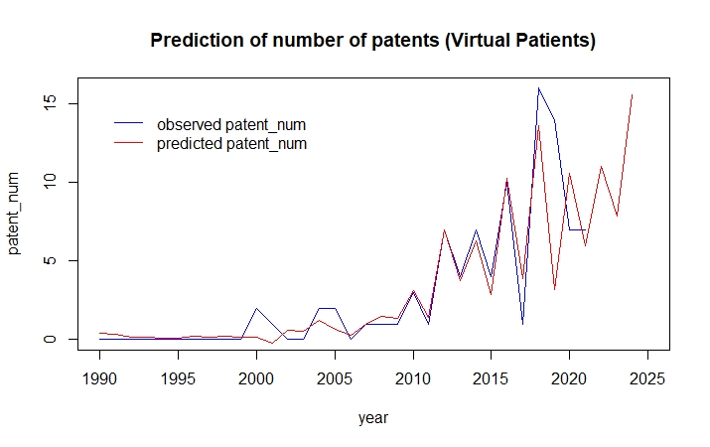

|  |  |  |  |
| --- | --- | --- | --- |
| word | TF | DF | TF_IDF |
| glucose | 66 | 13 | 123.538944 |
| virtual | 58 | 19 | 87.8773795 |
| data | 51 | 17 | 82.6448752 |
| nitrogen | 45 | 15 | 78.2221853 |
| insulin | 39 | 12 | 75.8904958 |
| patient | 77 | 33 | 75.8064216 |
| system | 66 | 30 | 71.0735719 |
| simulation | 39 | 15 | 67.7925606 |
| device | 32 | 11 | 64.8304914 |
| model | 44 | 20 | 64.518831 |
| methods | 61 | 31 | 63.7525398 |
| user | 27 | 9 | 59.6234092 |
| healthcare | 26 | 9 | 57.4151348 |
| error | 18 | 3 | 56.2421726 |
| sensor | 21 | 6 | 53.8639365 |
| drug | 32 | 16 | 53.6846772 |
| medical | 34 | 18 | 53.2582979 |
| method | 58 | 36 | 52.1966124 |
| ammonia | 30 | 15 | 52.1481235 |
| scavenging | 30 | 15 | 52.1481235 |
| controller | 19 | 5 | 51.6629007 |
| level | 34 | 19 | 51.5143259 |
| physiological | 22 | 8 | 50.8999684 |
| least | 29 | 15 | 50.4098527 |
| cost | 16 | 3 | 49.9930423 |
| computer | 27 | 14 | 48.6758512 |
| training | 28 | 15 | 48.671582 |
| information | 26 | 13 | 48.6668566 |
| image | 21 | 8 | 48.5863335 |
| mpc | 15 | 3 | 46.8684772 |

1. Whole-Genome Synthesis

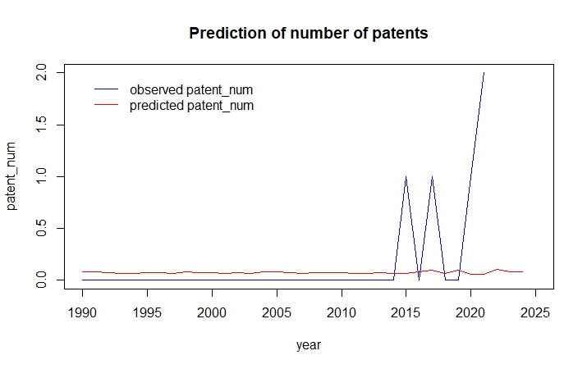

|  |  |  |  |
| --- | --- | --- | --- |
| word | TF | DF | TF_IDF |
| optical | 9 | 1 | 9.8875106 |
| perception | 8 | 1 | 8.78889831 |
| depthimage | 7 | 1 | 7.69028602 |
| layer | 7 | 1 | 7.69028602 |
| sensor | 10 | 2 | 6.93147181 |
| information | 6 | 1 | 6.59167373 |
| map | 6 | 1 | 6.59167373 |
| module | 6 | 1 | 6.59167373 |
| object | 8 | 2 | 5.54517744 |
| constructing | 5 | 1 | 5.49306144 |
| robot | 7 | 2 | 4.85203026 |
| area | 4 | 1 | 4.39444915 |
| image | 4 | 1 | 4.39444915 |
| material | 4 | 1 | 4.39444915 |
| photoconductive | 4 | 1 | 4.39444915 |
| mode | 4 | 1 | 4.39444915 |
| least | 5 | 2 | 3.4657359 |
| system | 5 | 2 | 3.4657359 |
| colored | 3 | 1 | 3.29583687 |
| dynamic | 3 | 1 | 3.29583687 |
| cover | 3 | 1 | 3.29583687 |
| treatment | 3 | 1 | 3.29583687 |
| audio | 3 | 1 | 3.29583687 |
| audiovisual | 3 | 1 | 3.29583687 |
| rcu | 3 | 1 | 3.29583687 |
| visual | 3 | 1 | 3.29583687 |
| humans | 3 | 1 | 3.29583687 |
| apparatus | 4 | 2 | 2.77258872 |
| adjusted | 2 | 1 | 2.19722458 |
| adopted | 2 | 1 | 2.19722458 |

1. SCI Papers Analysis Data
2. AI led molecular design

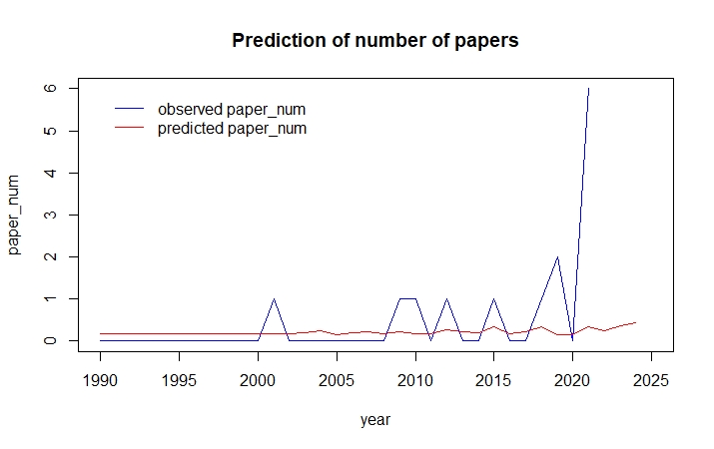

1. Algorithms for quantum computers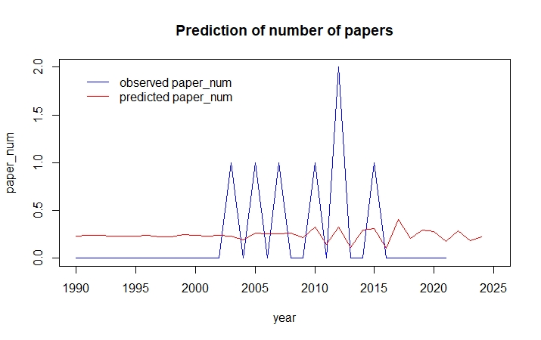
2. Augmented reality

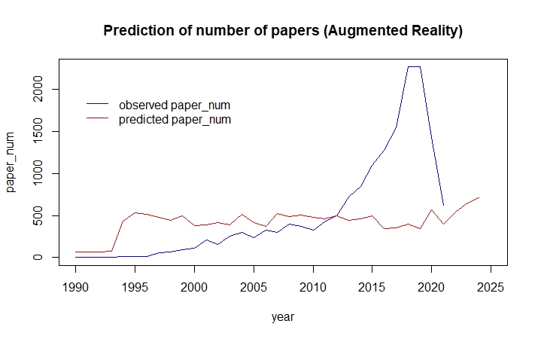

1. Bioplastics for a Circular Economy

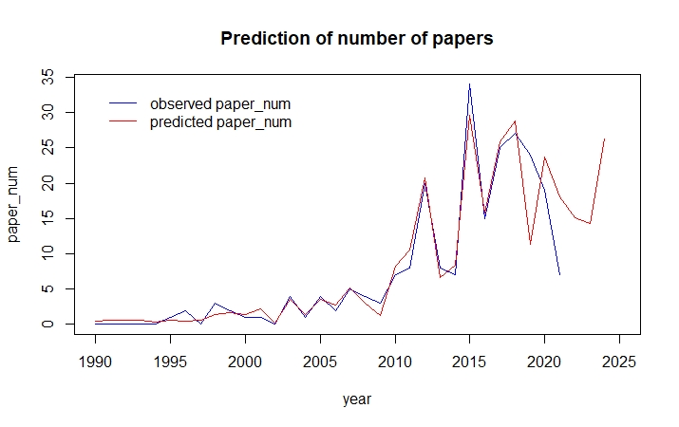

1. Breath sensors diagnose disease

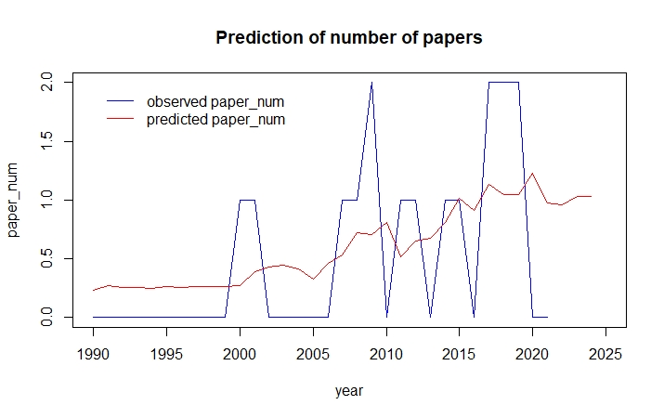

1. Collaborative Telepresence

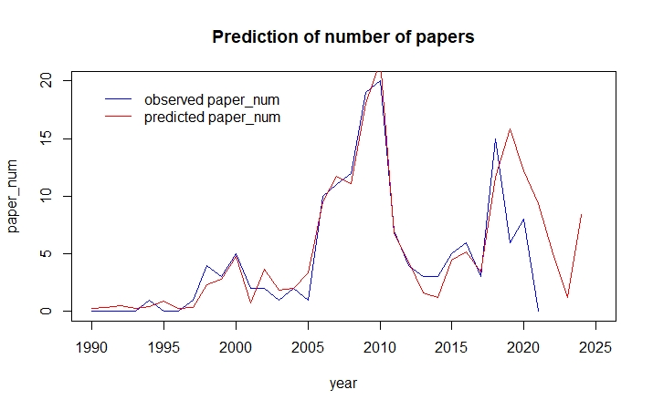

1. Decarbonization rises

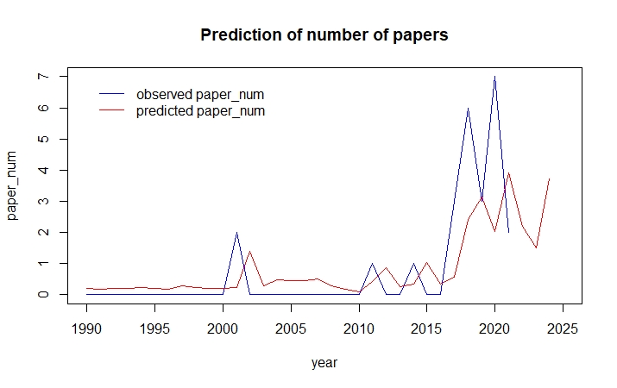

1. More capable digital helpers

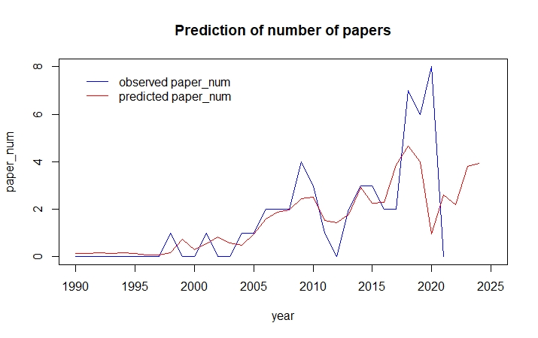

1. Digital Medicine

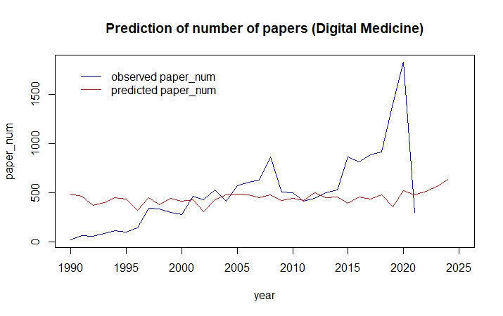

1. Disordered Proteins as Drug Targets

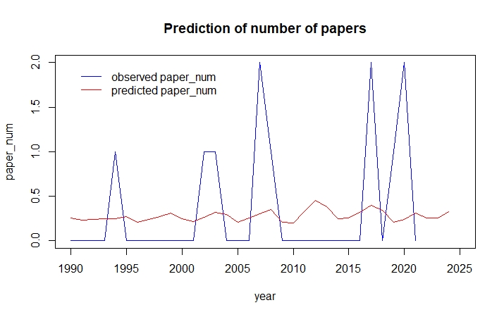

1. DNA Data for Storage

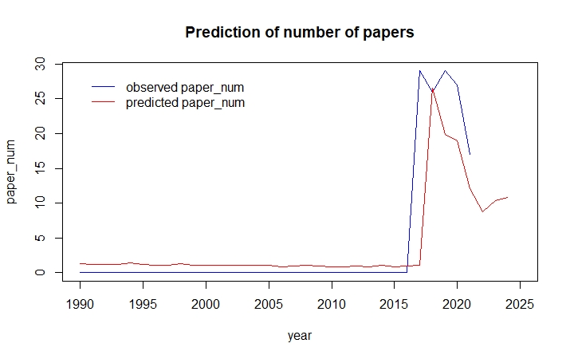

1. Implantable drug-making cells

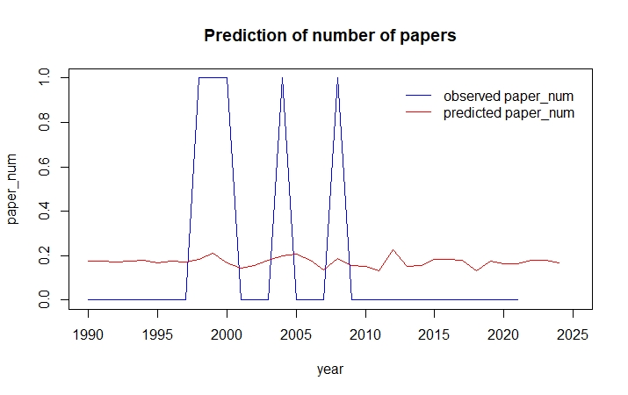

1. Electric Aviation

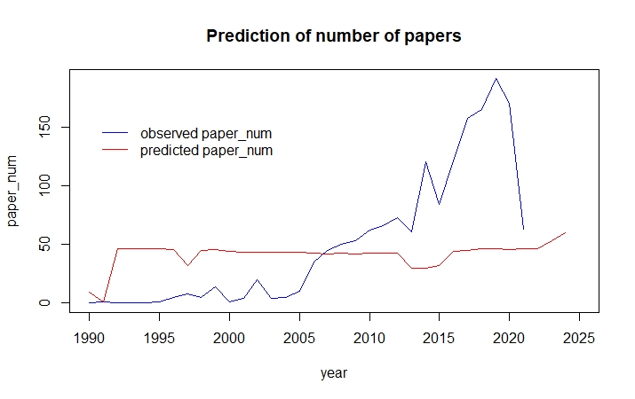

1. Electroceuticals

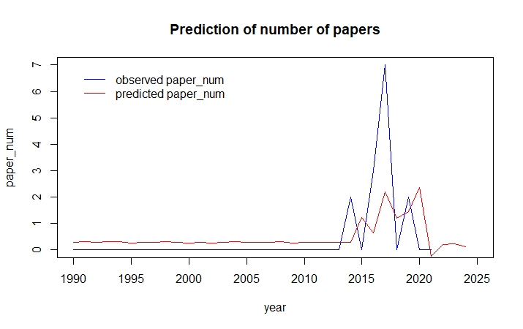

1. Advanced Food Tracking and Packaging

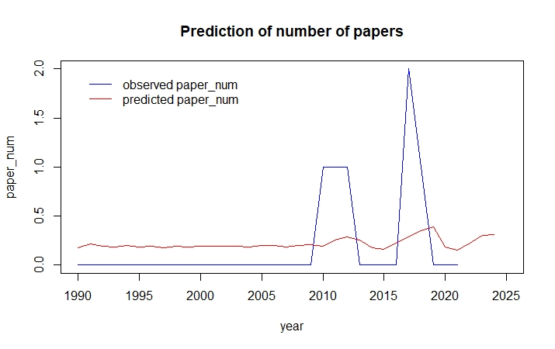

1. Gene drive

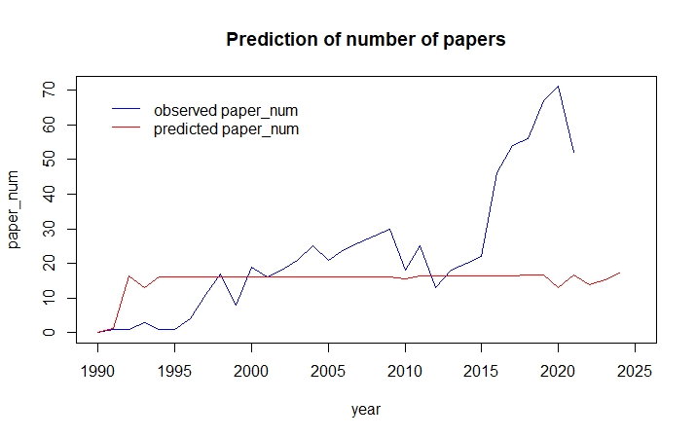

1. Green ammonia

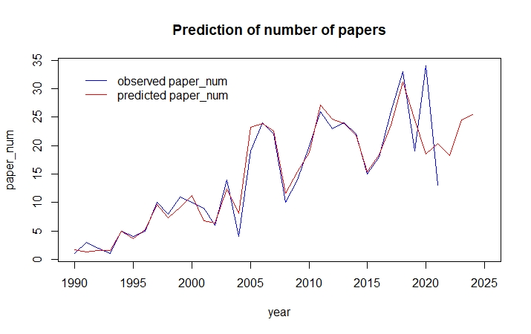

1. Green Hydrogen

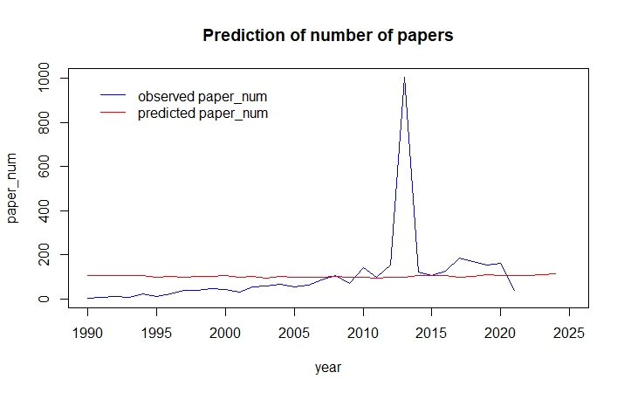

1. Lower-Carbon Cement

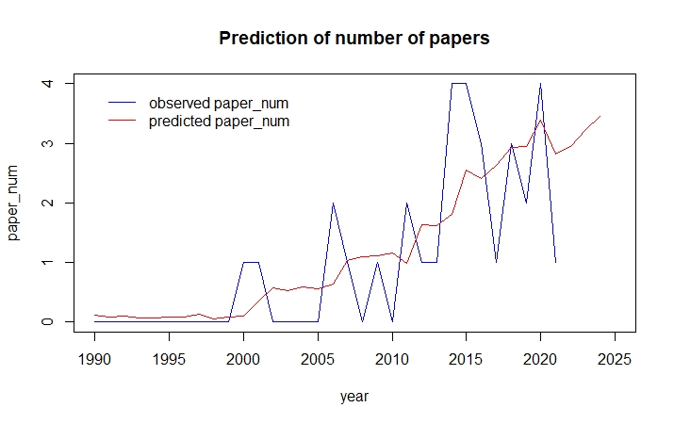

1. Microneedles for Painless Injections and Tests

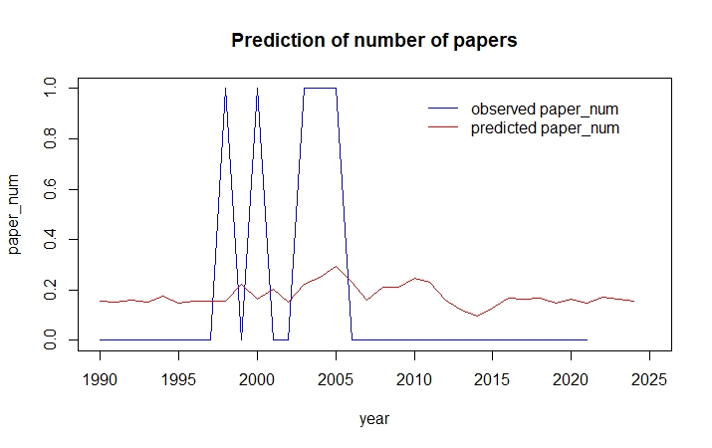

1. On-demand drug manufacturing

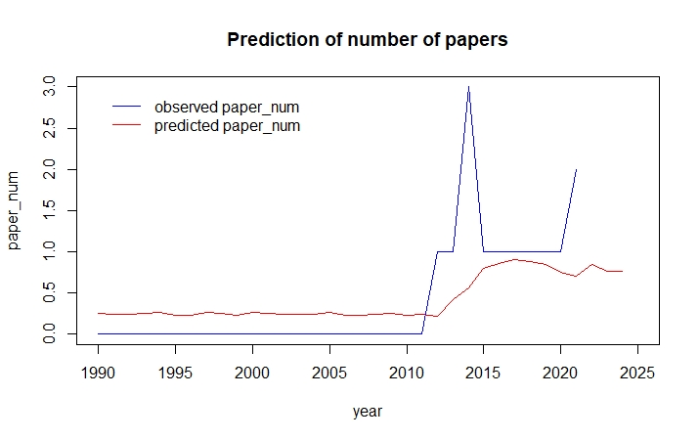

1. Personalized medicine

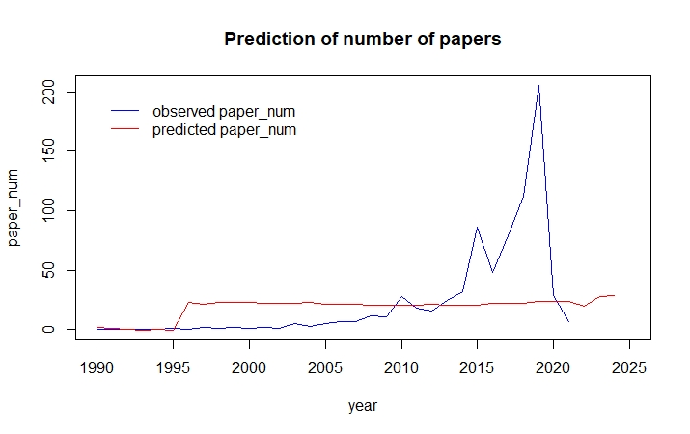

1. Plasmonic materials

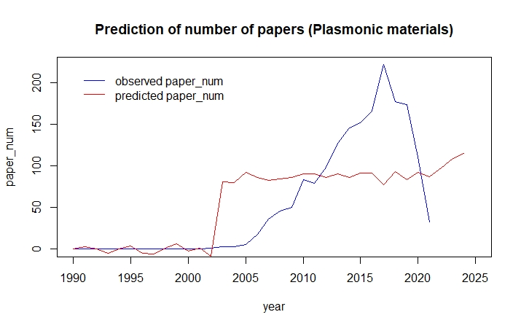

1. Quantum Sensing

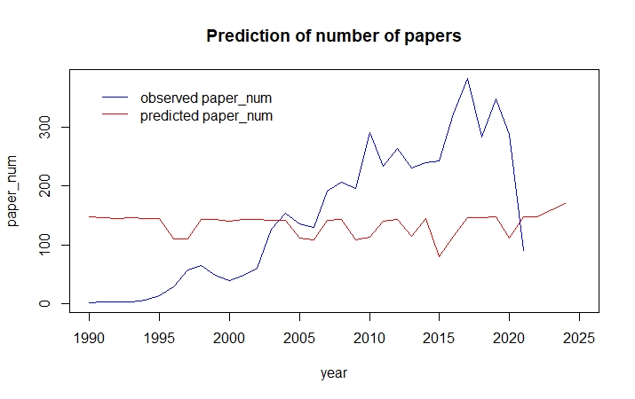

1. Safer Nuclear Reactors

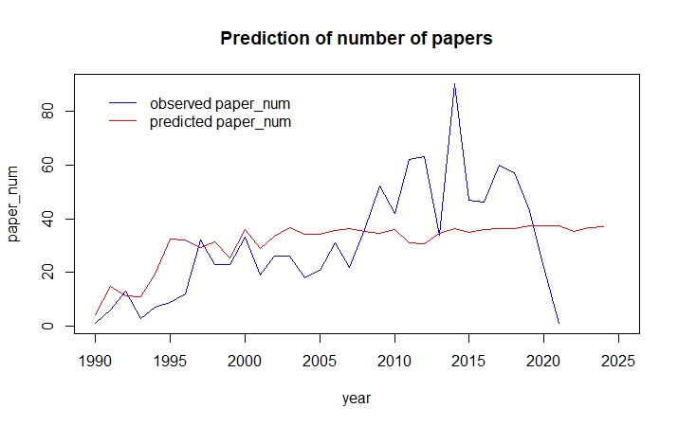

1. Smarter Fertilizers Can Reduce Environmental Contamination

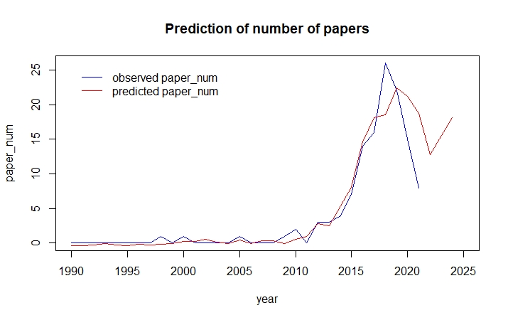

1. Social Robots

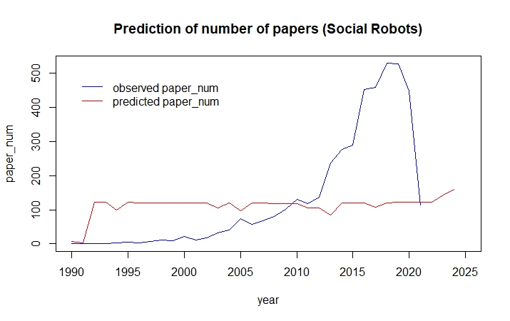

1. Spatial Computing

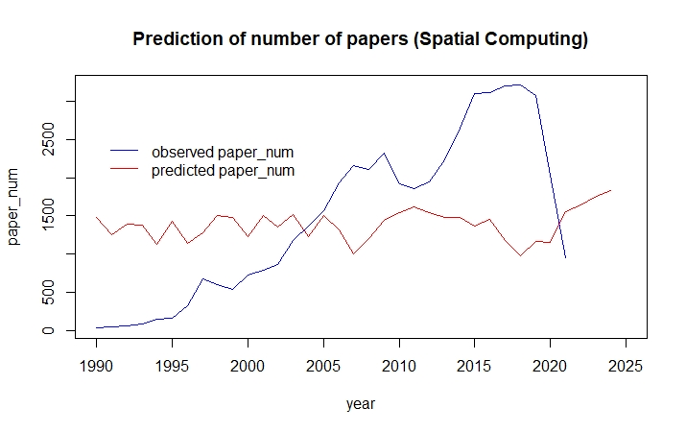

1. Utility-Scale Storage of Renewable Energy

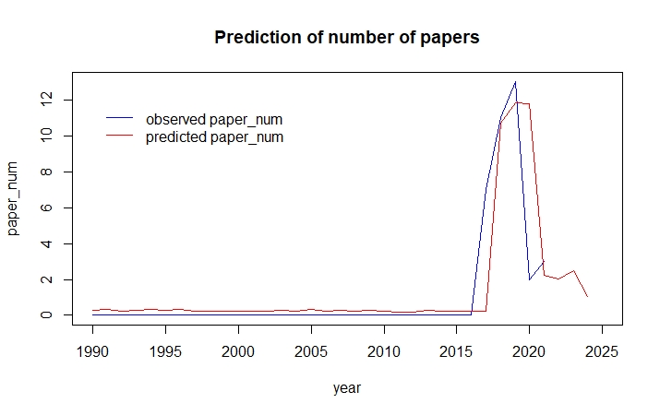

1. Tiny Lenses for Miniature Devices

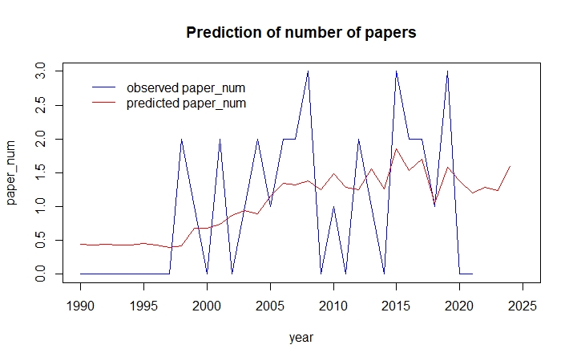

1. Virtual Patients

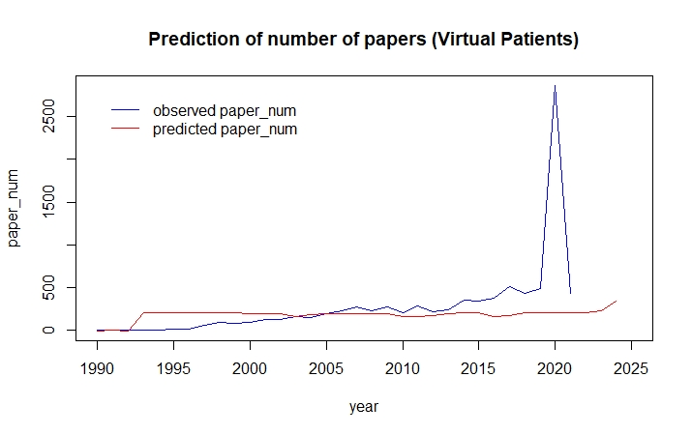

1. Whole-Genome Synthesis

